Chapter 2: Summary Measures of Statistics

The Excel spreadsheet file Chap2_LabExercise2.xls contains the data to be used in the following tasks. All your answers must be shown in the spreadsheet.

Tasks

- For each table in Statistics worksheet, use the following formulae to find the mean and standard deviation:

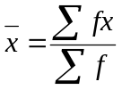, 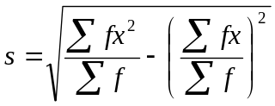

- The weekly payment, take to the nearest $, of 200 factory workers were recorded and are summarised in the grouped frequency distribution in Cumulative Table worksheet.
(a) Create a cumulative frequency table in the same worksheet. You may find the Excel built-in function SUM useful here.

(b) Use the cumulative frequency table in (a) to construct a cumulative frequency polygon (Ogive).

- The spending, take to the nearest $, by Malaysian and Thai tourists during their stay at a holiday resort. The data are shown in Tourist Data worksheet.
(a) (i) Use the built-in Excel functions AVERAGE, MODE and STDEV to find the mean, mode and standard deviation of spending by
(A) Malaysian tourists
(B) Thai tourists

(ii) Find the coefficient of variation (CV) of spending by
(A) Malaysian tourists
(B) Thai tourists

The formula for CV = 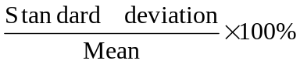

Comment on the variation of the distribution for tourists from the two countries.

(iii) Find the Pearsonian measure of skewness for each nationality. Comment of the skewness for each nationality. You may use the Excel built-in function SKEW to perform the task.

(b) Find the first and third quartiles for the spending. Use the built-in Excel function QUARTILE to perform the task.

4. On a certain day the number of books on 40 shelves in a library was noted and grouped as shown. Draw a histogram and an ogive.

Number of books | 31 – 35 | 36 – 40 | 41 – 45 | 46 – 50 | 51 – 55 | 56 – 60
Number of shelves, f | 4 | 6 | 10 | 13 | 5 | 2

5. The table shows the masses of a group of male students at a college. Draw a histogram and an ogive.

Mass (kg) | 60 – 64 | 65 – 69 | 70 – 74 | 75 – 79 | 80 – 84 | 85 – 89
Frequency | 4 | 27 | 42 | 60 | 35 | 12

